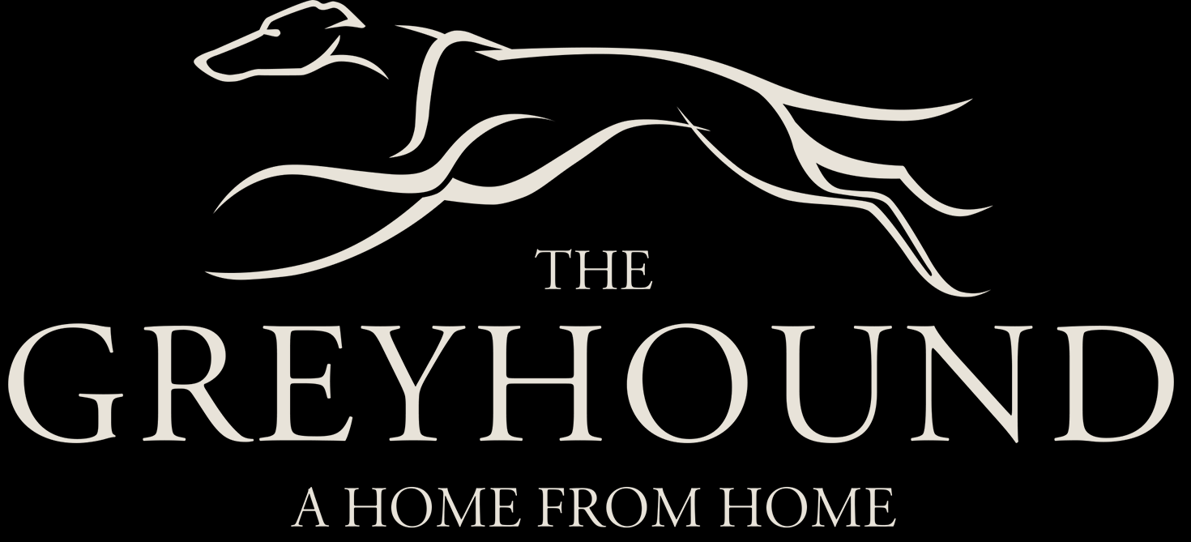

Starters
Home Made Soup | £4.95 |  | Salt & Pepper Calamari | £5.95
Garlic Mushrooms | £4.95 |  | Scampi | £5.95
Grilled Halloumi | £5.95 |  | Chorizo Malbec | £5.95
Main Courses
Cumberland Sausage served with Mash Potato and Peas. A Vegetarian option is available | £9.95 |  | Vegetable Curry served with rice and a side of Saag Aloo | £12.95
Vegan Mushroom Pie, Seasonal Vegetables with choice of Roast or Mashed Potatoes | £12.95 |  | Cottage Pie with a side of seasonal vegetables | £9.95
Chicken Curry Gram masala with a Side of Spiced Rice & Saag-Aloo | £12.95 |  | Mixed Grill: Cumberland sausage, Chicken filet, Steak, Gammon, Fried Tomato, Mushroom & Chips | £14.95
Chicken Tikka Jalfrezi with a Side of Spiced Rice & Saag Aloo | £12.95 |  | Mango and Lime Chicken Salad | £10.95
Spaghetti Arrabbiata | £9.95 |  | Gnocchi Arrabbiata | £9.95
Spaghetti Bolognese | £9.95 |  | Gnocchi Bolognese | £9.95
Off The Bone Ham, Eggs, and Chips | £10.95 |  | Scampi & Chips served with Garden or Mushy peas | £10.95
Gammon, Eggs And Chips | £10.95 |  | Calzone Volcanico | £12.95
For allergy information, please consult our Chef

Hamburgers And Sandwiches
Big Bear Burger  ¼ Beef pound, egg, bacon, cheese, salad, Cheddar & fries | £12.95 |  | Big Bear Chicken Burger  ¼ Chicken pound, egg, bacon, cheese & fries | £12.95
Big Bear Chilli Burger served with Chilli, Cheese and Arabiatta Salsa | £12.95 |  | Big Bear Blue Cheese Egg, Bacon, Salad & Fries | £12.95
Big Bear Double
¼ Chicken pounder, ¼ Beef pound egg, Chilli, bacon, Salad, cheese & fries
£14.95

Bigbear Smoke House Vegan Burger is in production | £12.95 |  | Sausage Sandwich  Toasted on Request | £4.95
Bacon Sandwich  Toasted on Request | £4.95 |  | Off the bone Ham and Tomato Sandwich | £4.95
All Day Breakfast Sandwich Sausage, Bacon and Egg.  Toasted on Request | £6.95 |  | Chilli Dawg  An All American Hotdog served with chilli, cheese, relish or fried onions and a sauce of choice | £5.95
For allergy information, please consult our Chef

Desserts
Home-Made Apple Pie & Custard | £5.95 |  | Eton Mess | £5.95
Chocolate Brownie & Ice Cream | £5.95 |  | Home Made Cheesecake | £5.95
Ice Cream | £4.95
For allergy information, please consult our Chef

