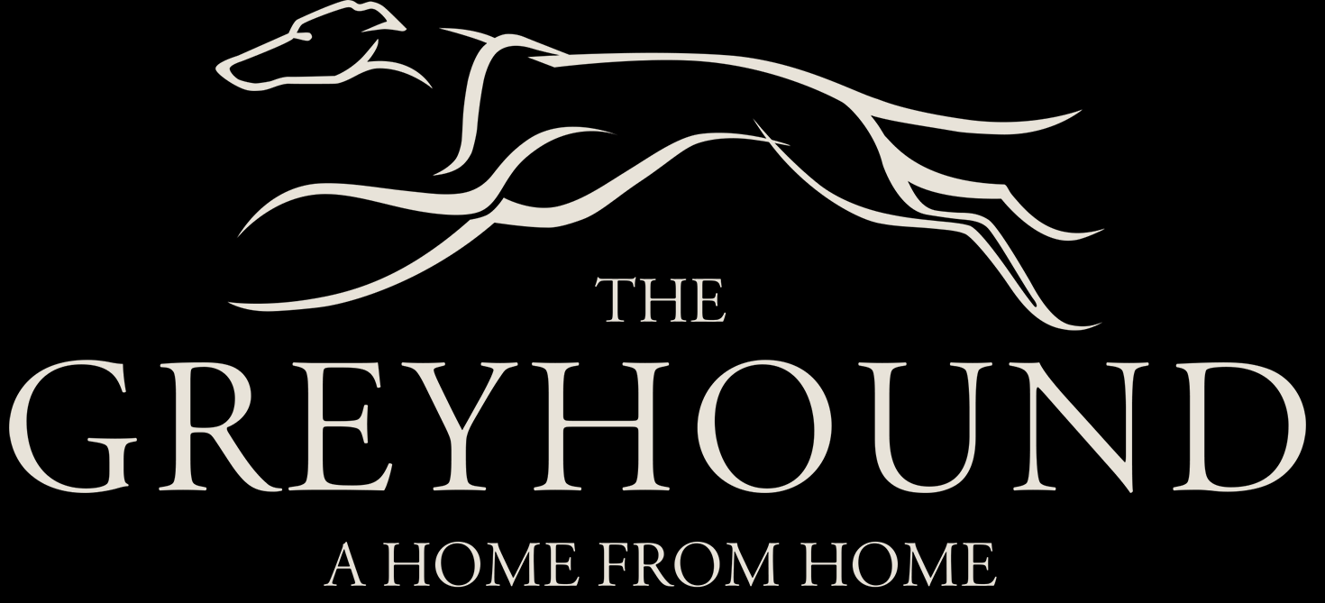

Christmas Menu

Starters
Home-made Broccoli & Blue Cheese Soup
Fresh Pate on Toast
Prawn Cocktail served with Traditional
Seafood Marie Sauce

Main Courses
Locally sourced Roast Turkey with Traditional Festive Trimmings
Fresh Salmon served with Dill
Mashed Potatoes and Seasonal Vegetables
Vegan Mushroom Pie served with Mashed Potatoes and Seasonal Vegetables

Desserts
Traditional Eton Mess
Luxuries Chocolate Brownie with
West Country Ice Cream
Traditional Xmas Pudding served with VSOP Brandy Sauce

Three Courses £24.99
Two Courses £21.99
For allergy information, please consult our Chef

