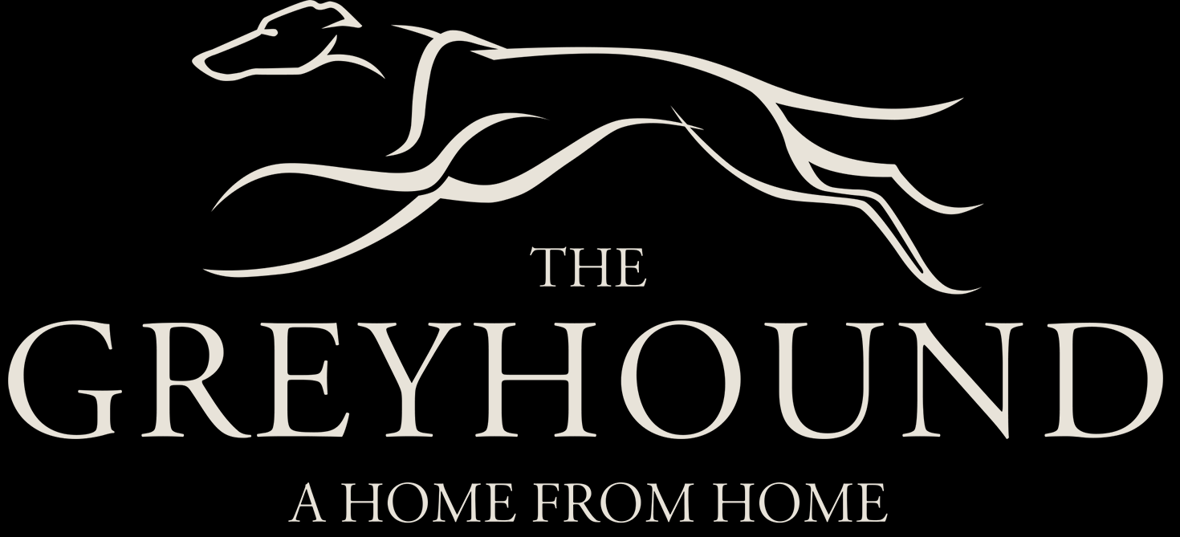

Breakfast Menu
All Day Breakfast Sandwich  Sausage, Bacon and Egg  Toasted on Request | £5.95 |  | Big Bear Brunch  2 Cumberland Sausages, 2 rashers of Bacon, 2 Free Range Eggs, Bubble & Squeak, Beans, Mushrooms, Tomato Toas | £9.95
Eggs Cubana  Scrambled eggs mixed with Chorizo and chilli served with a Salsa dip | £6.95 |  | Full English  Cumberland Sausage, Bacon, Free Range Egg, Mushroom, Tomato & Toast | £6.95
Poached/Scrambled Eggs on Toast | £4.50 |  | Eggs Benedict | £6.95
Sausage Sandwich  Toasted on Request | £4.95 |  | Bacon Sandwich  Toasted on Request | £4.95
Chilli Dawg  All American Hotdog served with chilli & cheese | £5.95 |  | Smashed Avocado and Poached eggs on Toast  Add Bacon £6.95  OR Smoked Salmon £7.95 | £5.95
For allergy information, please consult our Chef

